Eventi
Use Case Specification

Submitted to:

Asst. Prof. Ma. Rowena C. Solamo
Faculty Member
Department of Computer Science
College of Engineering
University of the Philippines, Diliman

Submitted by:
Dimaano, Aaron Diego I.
Lopez, Matthew S.
Torres, Jacob Angelo V.

In partial fulfillment of academic requirements
for the course
CS 191 Software Engineering I
of the
1st Semester, AY 2015-2016
Unique Reference:
The documents are stored in https://github.com/Tom-2013-06417/CS191-192_Event_Sharing/tree/master/02-Requirements%20Engineering.
Link to this document:

Document Purpose:
The purpose of this document is to exhaust the step-by-step process of the Use Cases in every scenario possible.

Target Audience:
To our project client and adviser, our fellow 191 classmates, and our future selves when they need to refer back to this document.

Revision Control:

Revision Date | Person Responsible | Version  Number | Modification
09/18/15 | Dimaano, Diego  Lopez, Matthew  Torres, Jacob | 1.0 | Initial Document

Use-Case Name: Sync database with Mobile App

Description: By synchronizing the web application with the mobile application, Eventi’s reach is widely broadened, providing the app with more coverage. This entails that we have to synchronize our directions, goals, and maybe even interface as well, as to avoid confusion amongst applicants’ nor alumni.

Preconditions: There is an internet connection to the Eventi server and a mobile device with browsing capabilities. The mobile application must have also been installed in the said mobile device.

Flow of Events:

Scenario Name | Description
Scenario 1 (Basic Flow)  Mobile App synchronization with Web Site (databases) | 1. Mobile App downloads database information from the System
Scenario 2  Mobile App fails to synchronize with Web Site (databases) | 1. Troubleshoot connectivity  2. Troubleshoot software  3. Check for information online  4. If successful, proceed with synchronization
Scenario 3  Mobile App fails to synchronize with Web Site (databases) | 1. Troubleshoot hardware  2. Troubleshoot software  3. Check for information online  4. If unsuccessful, elect to give up

Activity Diagram of the Flow of Events:

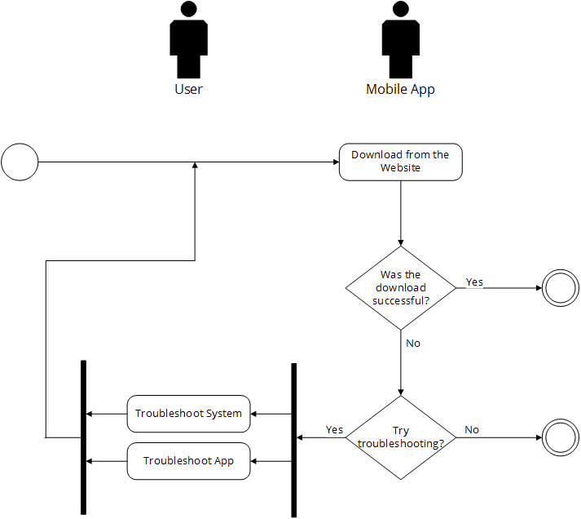

Post-conditions: Successful: The Eventi homepage has successfully loaded and the events are shown. The database of the mobile app was also able to be synchronized with that of the web site.
Failed: The website did not load. The mobile app failed to synchronize

Special Requirements: NONE

